**MISSION STATEMENT**

Hunt County Head Start/L. P. Waters ECLC is committed to providing quality child development services to eligible children in Hunt County. This will be accomplished in a safe, orderly and nurturing environment for intellectual, emotional, social and physical growth to enhance the quality of life for children and their families.

[](http://www.bing.com/images/search?q=head+start+icons&id=9202D315B4CC728EACF3BDED0E52965ABD1B756B&FORM=IQFRBA)

**TRIENNIAL MONITORING VISIT**

The Hunt County Head Start program was found to be in full compliance with all applicable Head Start Performance Standards, laws, regulations and policy requirements during its 2011-2012 onsite monitoring visit by the Office of Head Start. Our next monitoring has just been announced and will be in the years 2015 and 2015likely this Spring. We will receive a 30 day advance notice.

An area of strength for our Head Start program as noted by our last review is in the area of technology

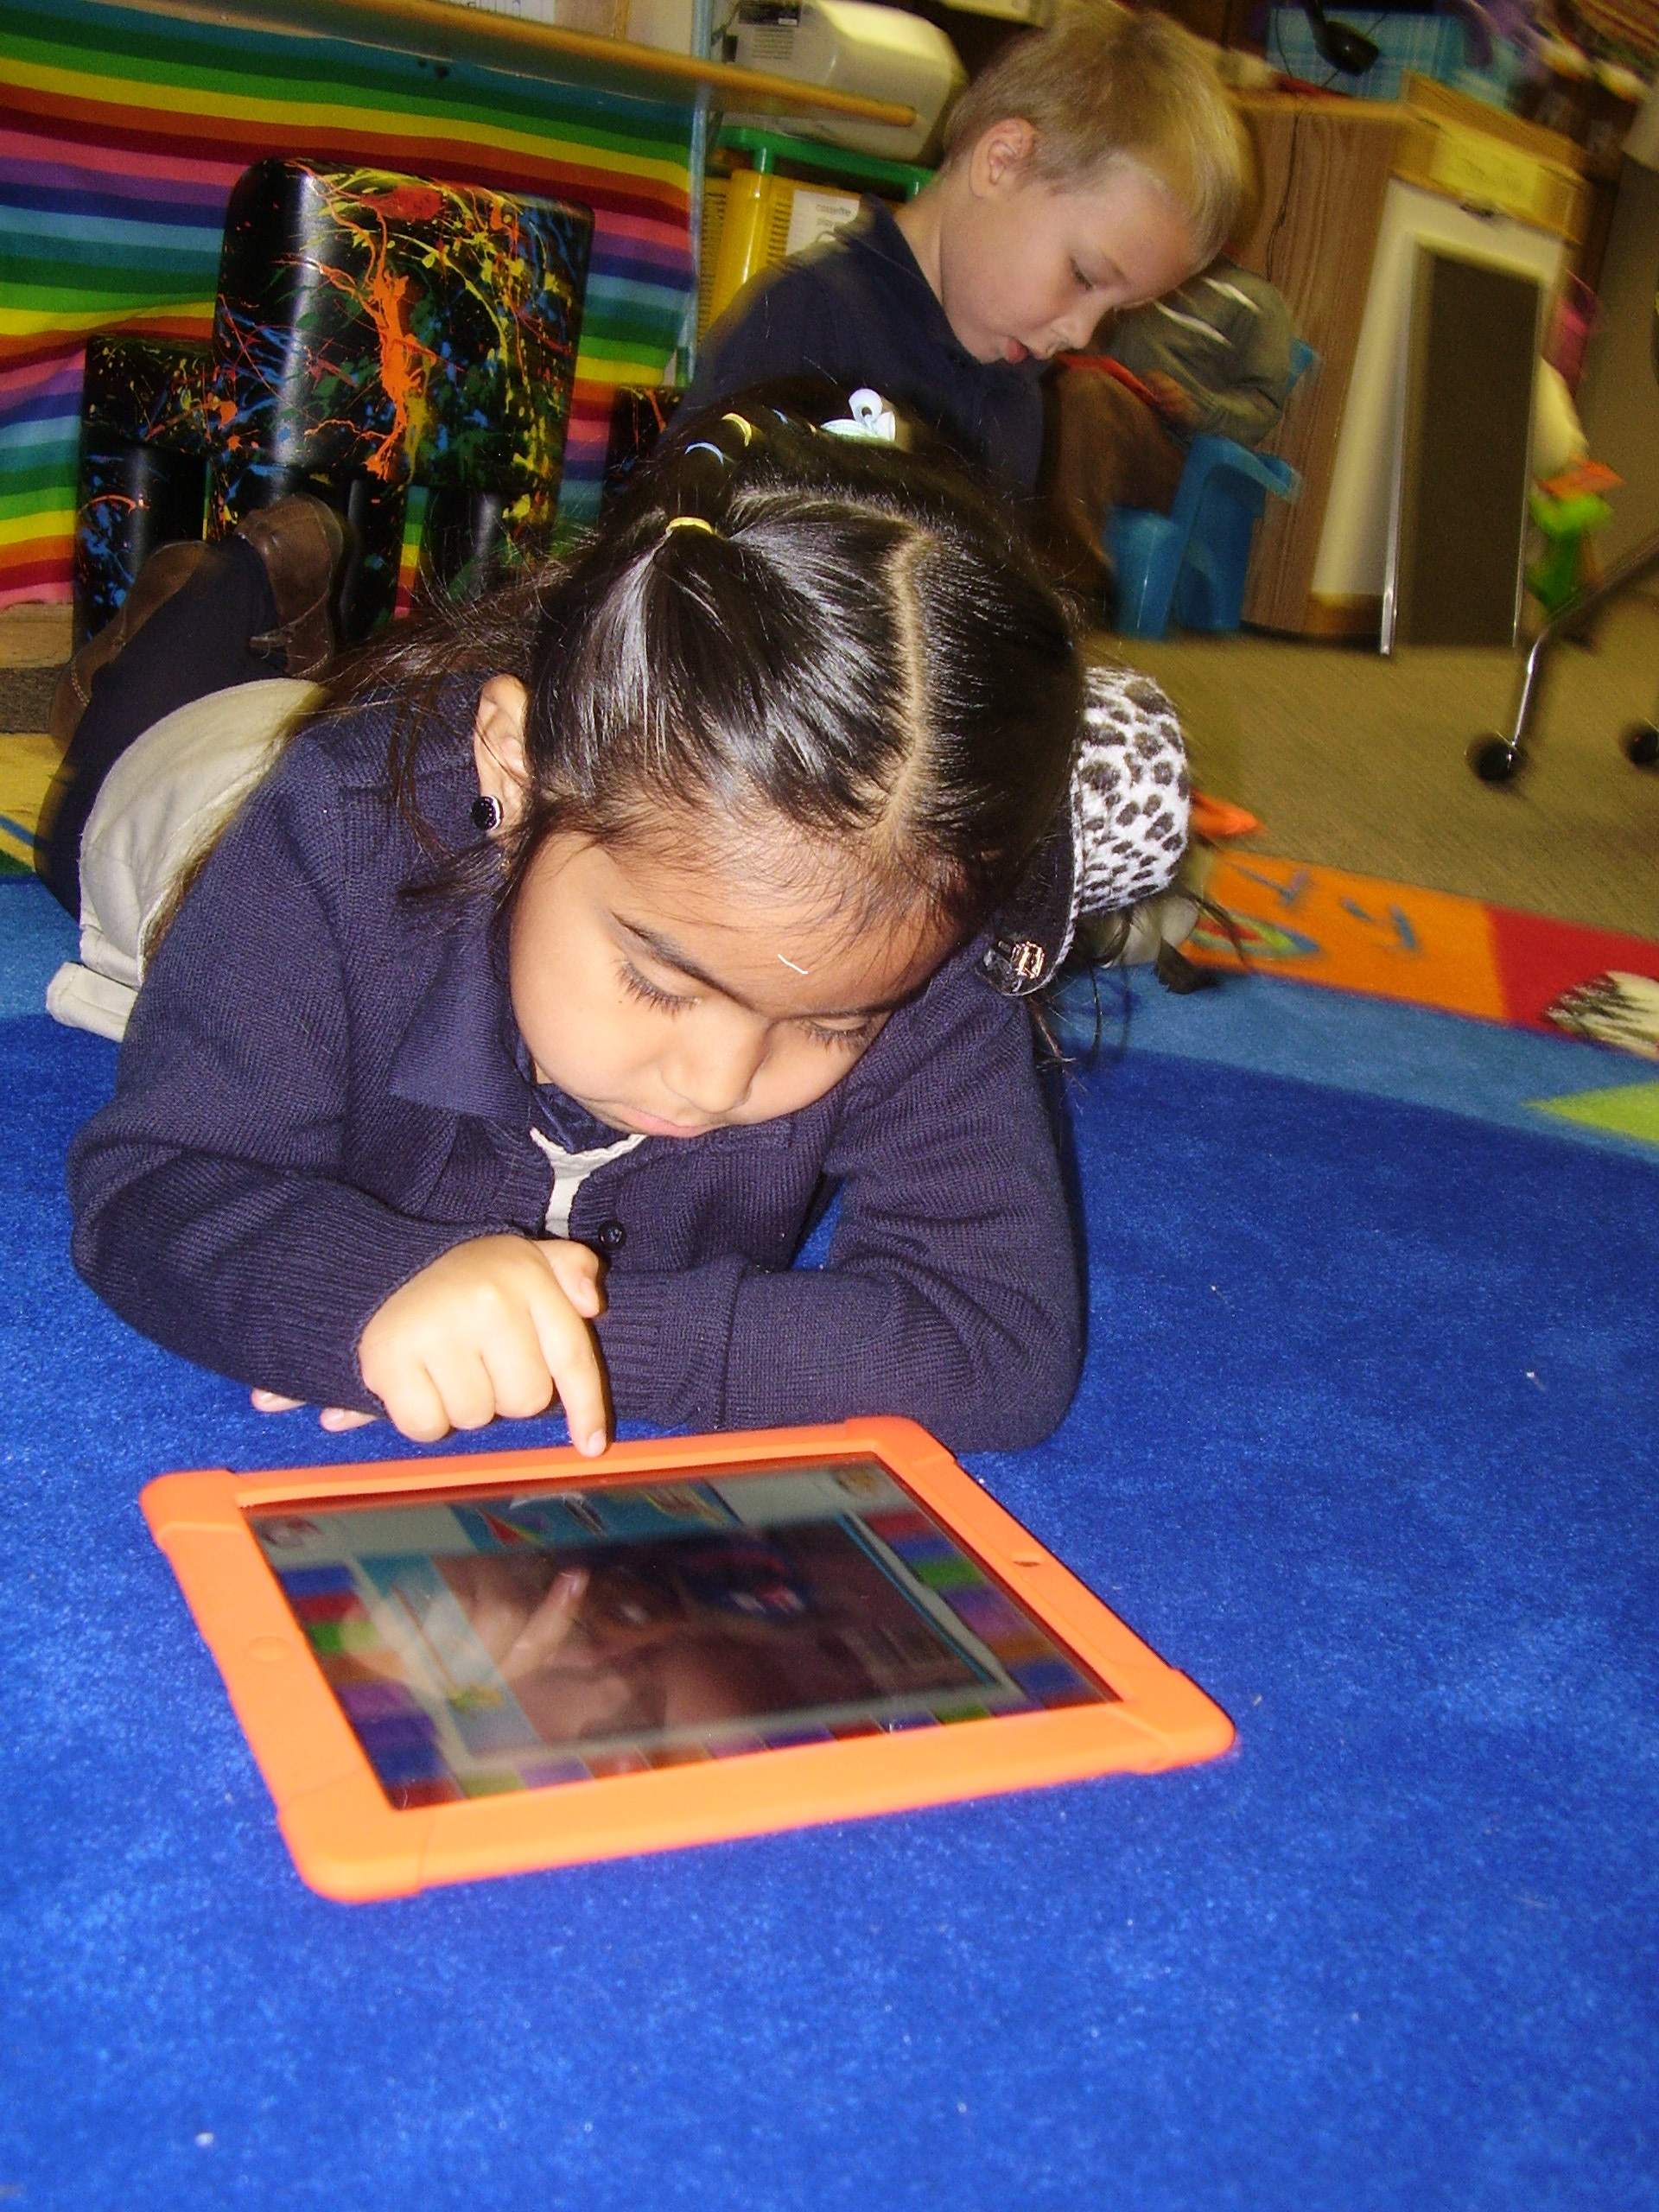

Hunt County Head Start uses technology to augment education in all classrooms. There is a computer lab at all sties for use by parents and staff. Promethean boards have been installed in all classrooms at the L.P Waters Center and the single classroom at the Commerce site, allowing teacher to design and implement interactive activities for children both individually as a group. This past year, the Commerce recently piloted an iPad work station for their students. Teachers report an increased ability to share curriculum activities across classrooms. In 2014, our Greenville site partnered with Greenville ISD to provide iPads to all teachers for assessment and classroom use Mini iPads were also ordered for student use. Promethean boards at all sites continue to facilitate and enhanced the use of our curriculum including children’s books, sorting, language development, math and science skills, and logic and reasoning.

Computer labs are used in parent training, and for Child Development Associate (CDA) training for teacher aides to received required certification. The Galileo web based software is in its fourth year of implementation and is used by teachers to track children’s progress and drive instruction. It is also used by the Education Coordinator to analyze data on children and classrooms related to the Head Start Early Childhood Outcomes Framework, the Texas standards for Early Childhood Education, and school readiness.

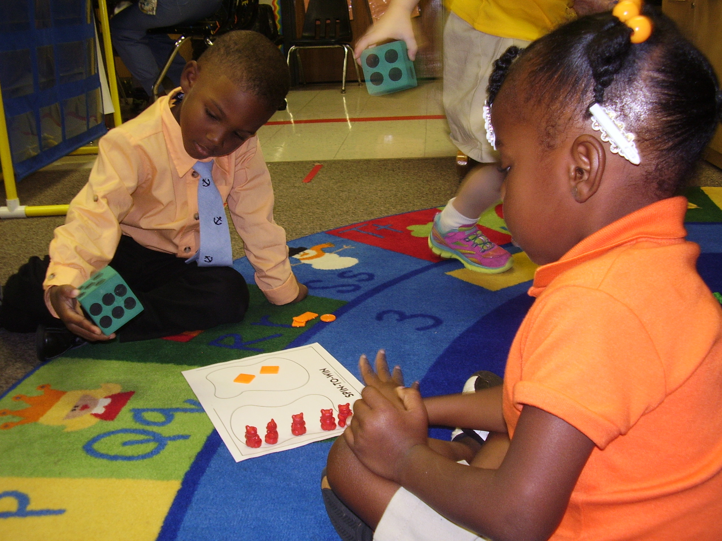

**ANNUAL FINANCIAL AUDIT**

Greenville Independent School District was found to be in full compliance during its last annual financial audit. Our Hunt County Head Start program was also found to be in full compliance with all applicable Head Start Performance Standards, laws, regulations and policy requirements during its 2012-2013 onsite monitoring visit by the Office of Head Start. Our Grantee, Greeinville ISD has received a superiod rating on our last three financial audits.



**BUDGETARY EXPENDITURES**

* Personnel and Fringe Benefits
* Supplies for Classroom, Office, Family Services, Health, Disabilities, and Parent Involvement
* Maintenance and Renovations
* Library Expenses
* Library Books/Supplies
* Mental Health Assessments
* Snacks
* Contracted Services
* Staff Training and Technical Assistance
* Staff and Parent related travel (local and out-of-town)
* Medical and Dental Services
* Child Liability
* Substitutes
* Field Trips

**COLLABORATIONS / PARTNERSHIPS**

* Texas AgriLife Hunt County Extension
* Drug Free Greenville
* GISD Preschool Program for Children with Disabilities (PPCD)
* Local Elementary Schools
* Child Find
* Women Infants & Children
* Local Nursing Homes
* Local Daycares
* Greenville Adult Learning Center
* Dr. Maureen Weber, DDS.
* Raffa Clinic
* Senior Citizen Resource and Public Transit
* Redeemer Lutheran Church (Charlotte’s Closet)
* Knights of Columbus
* GISD Texas Literacy Initiative Grant (TLI)
* Greenville Fire Department
* Texas Literacy Grant- ESL CLASSES
* City Library

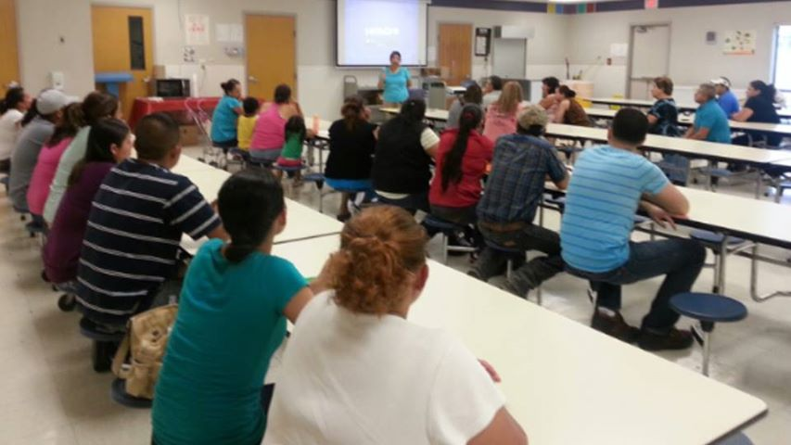

**EARLY CHILDHOOD DEVELOPMENT & HEALTH SERVICES**

* **161 children received Head Start services during the** 2013-2014 school year. These children participated in developmentally appropriate activities in a preschool classroom setting.
* **16 children with a diagnosed disability were served.** Each child identified with a disability was given an individualized education program (IEP), developed by specialists and parents. Each child’s IEP was customized to meet the child’s special needs. Progress reports were sent home at the end of each reporting period.
* **141 children were up-to-date** on a schedule of age appropriate preventive and primary healthcare, including all immunizations and physical exams. 88% of children enrolled in the program received medical and dental exams.

**PROGRAM DESIGN AND MANAGEMENT**

* **$1,081,392 was the dollar amount of the 2013-2014 Head Start budget** approved by the Administration for Children and Families. These funds provided Head Start services to 161 children and their families in Hunt County (this number exceeds funded enrollment slots). Greenville ISD Head Start also met the in-kind requirement of **$270,348.**
* **16 is the number of years that Hunt County Head Start** has been providing a comprehensive and high quality program to low-income children and their families.
* **8 parents and community members** served on the Policy Council for the 2012-2013 school year. The Policy Council provides parents and to participate in shared decision-making that covers program design and implementation of services.

**Brigance, Galileo, Portfolios, and Frog Street Press Curriculum** are the agency’s curriculum and assessment tools. These tools are used to collect and store information, allowing staff, and management to assess student and program performance. The Galileo system is correlated with the Head Start Outcomes. Its data helps determine the readiness level of each student and drives student instruction.

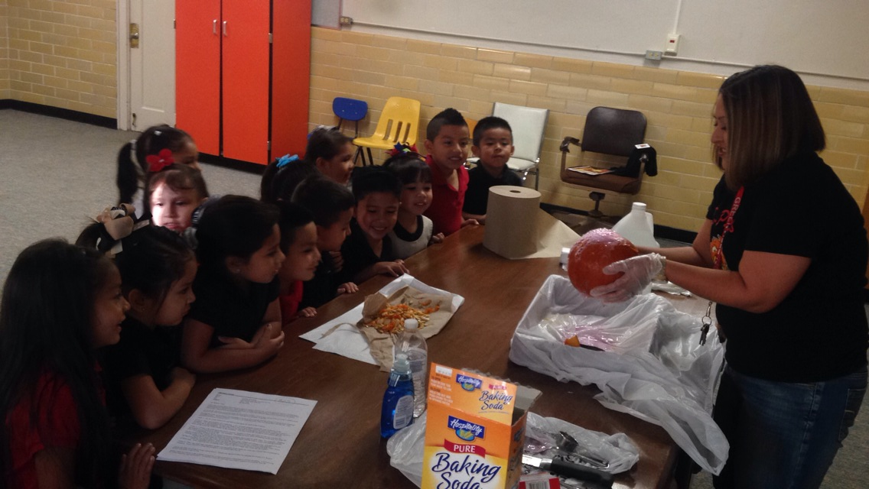

**FAMILY AND COMMUNITY PARTNERSHIPS**

* **90 volunteers** enhanced the quality of our Head Start Program in 2013-2014. They participated in various aspects, including assisting in the classroom, monitoring and evaluating the program, policy and procedure updates and over-all day to day operations. **Our Golden K volunteers, Greenville ISD Pals, Greenville Christian School Students and The Redeemer Lutheran Church** are dedicated, frequent volunteers.

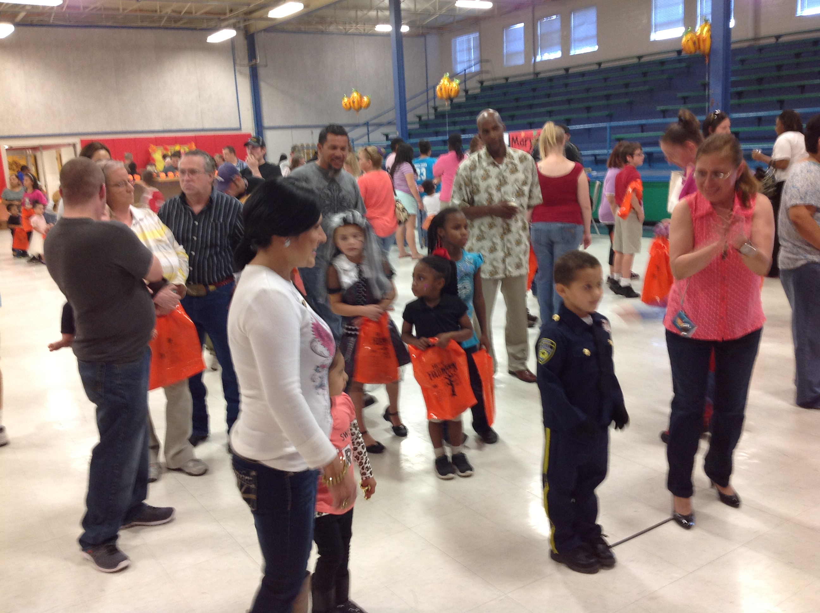

* **4** is the **number of current and/or former Head Start parents** employed by the program.
* **162** is the number of families in our Hunt County Head Start. **66** are two parent familiesand **96** are single parent families.
* Our **fathers** play essential roles. Many participate throughout our year and also participate in our FRED program where they read daily to the children.

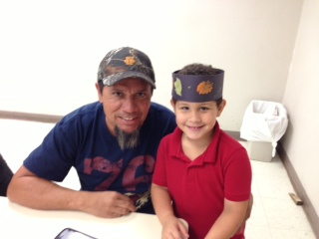

**RACE OF ALL CHILDREN ENROLLED IN THE PROGRAM FOR 2013-2014**

* African American: 34
* Caucasian: 47
* American Indian or

Alaska Native 71

* Biracial/Multi-Racial/Other 9

**ATTENDANCE**

**91% is the average attendance rate for 2013-2014**

$50,745 is the dollar amount reimbursed for Head Start Students through (CACPF) funds.

**LEARNING EXPERIENCES & FIELD TRIPS**

* Dairy Museum
* Nursing Home
* Pumpkin Patch
* Heard Museum
* Christmas Tree Farm
* Chuck-E-Cheese
* Aunt Char’s Playground
* Amazing Jakes (Pizza)
* Pump It Up
* Greenville Fire Department
* Drug-Free Greenville-Trike-a-Thon
* Planetarium (Commerce, TX)
* Talent Show
* Time for Santa
* Skate Safari
* Easter Egg Hunt
* Christmas Sing-A-Long and book give-away
* Elementary School Tours

**SCHOOL READINESS REPORT**

|  |  |  |  |
| --- | --- | --- | --- |
|  | **Beginning Level** | **Intermediate Level** | **Advanced Level** |
| **Approaches to Learning** | **3%** | **29%** | **66%** |
| **Creative Arts** | **21%** | **44%** | **35%** |
| **English Language Acquisition** | **5%** | **38%** | **57%** |
| **Physical Development and Health** | **.05%** | **29%** | **56%** |
| **Social and Emotional** | **20%** | **35%** | **45%** |
| **Logic and Reasoning** | **13%** | **38%** | **56%** |
| **Science** | **24%** | **63%** | **13%** |

**HUNT COUNTY HEAD START BELIEF STATEMENTS**

*All children can learn.

*Young children learn best from each other and

through doing, exploring, and creating.

*Children’s play is a primary vehicle by which

children learn and an indicator of their mental

growth.

*Learning should be meaningful and useful.

*An effective classroom is a reflection of the

community and is responsive to individual,

cultural, and linguistic differences.

*Developmentally appropriate practices are

implemented in all classes for young children.

*The Pre-Kindergarten Curriculum Guidelines,

Head Start Child Outcomes, and Preschool

Program for Children with Disabilities

Concepts are implemented to meet a variety of

developmental levels.

*Families are encouraged to participate in and

plan learning experiences for children.

*Children learn best when their relationships

with adults are consistent over time, emotionally

rewarding, and supportive.

*Children learn to their fullest potential when

their social, physical, emotional, and family

needs are met.

*The Head Start program supports the overall well-being of children and their families. The Head Start students are successful in Kindergarten.

**GROUP PRESENTATIONS/ TEACH PIECES**

* Pedestrian Safety
* Immunizations
* Buckle-Up
* Bedtime and Rest
* Name and Address
* Christmas-Sing Along
* Carols & Story Time
* Water Day
* Play Day
* Drug Free Greenville Trike Parade
* Drug Free Greenville Pep Rally (HS)
* Drug Free Greenville Walk Around the Block
* Fort Worth Children’s Opera (Little Red Riding Hood)

**PARENT ACTIVITIES/MEETINGS**

* Parent Orientation /Meet-the-Teacher
* Policy Council & Parent Committee
* Volunteer Training
* Child Abuse Training
* Pedestrian Safety
* Fire Safety
* Mental Wellness
* English Classes (day and night available)
* Toys for Tots
* Texas Health Steps
* Fathers Reading Everyday (FRED)
* Women in Need (CPS)
* Transition To Kindergarten Activities

**School Readiness Report-**



**SUMMARY**

This report has been compiled and distributed in fulfillment of Section 644(a)(2) of the Head Start Act. Hunt County Head Start will compile and distribute its annual report for the ***previous year*** each school year, in coordination with summary and submission of the Program Information Report (PIR) to the Office of Head Start (OHS).

The annual report will be distributed to the governing body and policy during a regularly scheduled meeting. It is also posted online. A hard copy is made available to staff and parents.